**CanSat Critical Design Review**

**– SatPlant –**

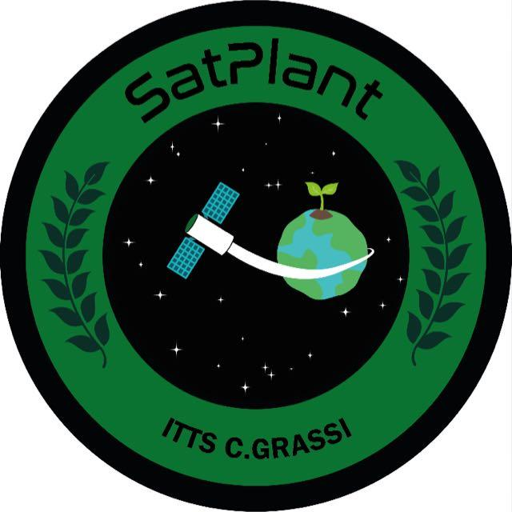

**Team Name: SatPlant**

**School Name: I.T.T.S. Carlo Grassi**

**Torino**

**Italy**

Sommario

Sommario

1. Introduction 4

1.1. Team organization and roles 4

1.2. Mission objectives 6

First Mission 6

Secondary mission – Planting a seed 6

2. Cansat description 8

2.1. Mission overview 8

2.2. Mechanical design 11

2.3. Electrical design 13

2.4. Software design 14

2.5. Ground station 15

2.7. Tests 16

3. Components and Costs Estimation 17

4. Outreach Program 18

4.1. The Official WebSite 18

4.2. Contacts & Community 19

4.3. Social Networks 19

4.4. Initiatives to increase the number of supporters and involve the public in the National Launch Campaign 20

4.5. Media Coverage & Meetings 20

5. Requirements 21

6. References 22

5. Appendix 1 – Sensors calibration 23

# Introduction

## Team organization and roles

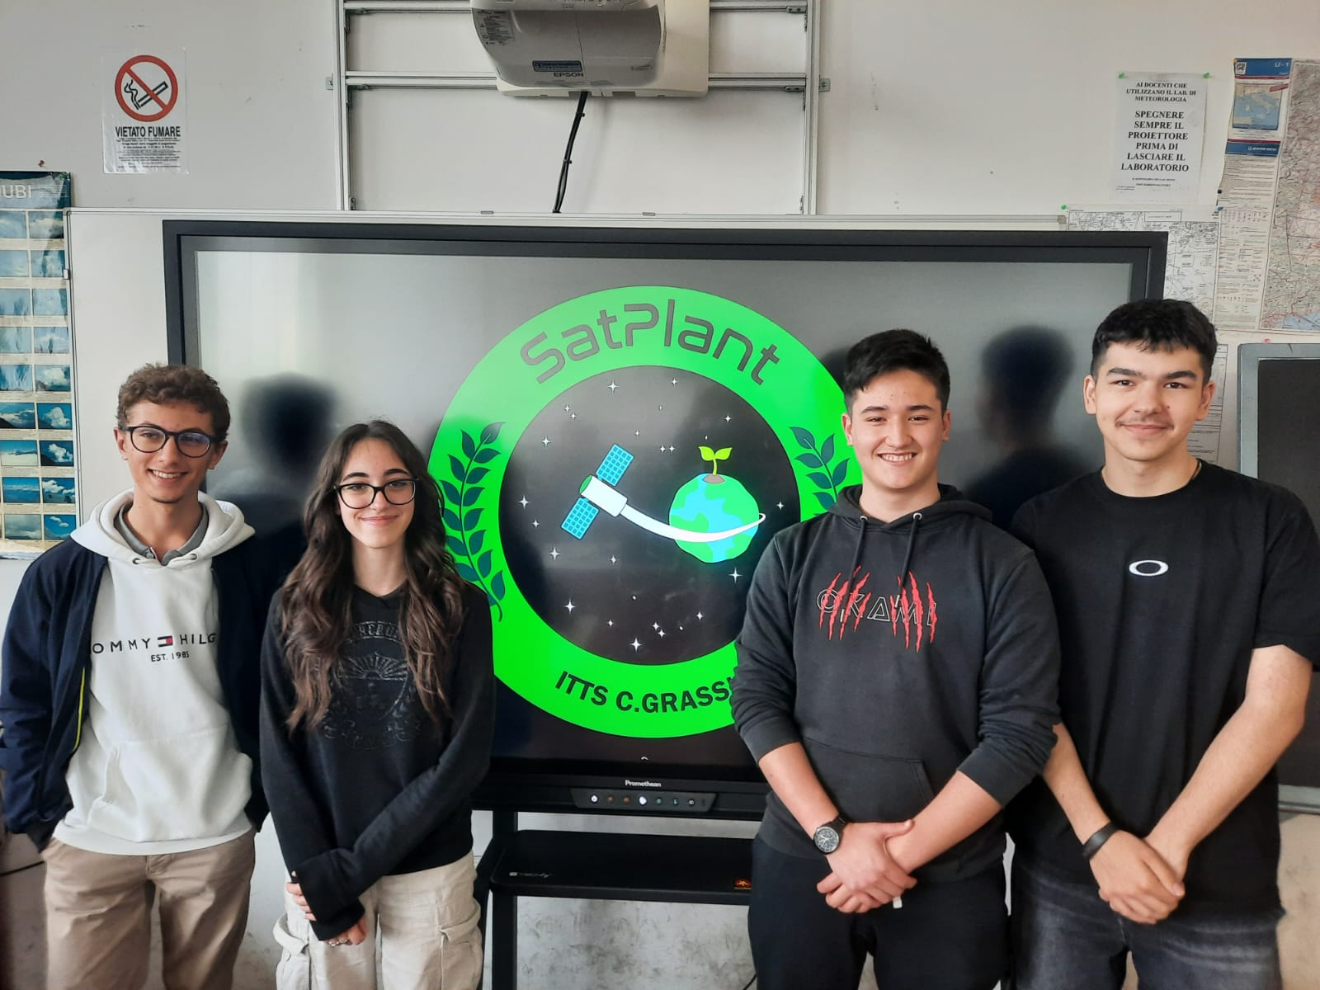

The group is composed of four students, from the left to the right: Leon Berretta, Amorino Desirée, Mei Stefano, Alexandru Tamas. The first three students belong to the same course while Alexandru is one year older and will soon face the final graduation exam.

* Alex: Electronic engineer

Alexandru is a student passionate about aviation who is about to conclude his school career in an experimental course in aircraft piloting. Alex has many passions and interests in many different fields, and now in his final year of study, he has the opportunity to put his knowledge and skills into practice on the CanSat project. This project is not just a task to be carried out, but represents a real training opportunity for Alexandru. His role in the project is to design and test the CanSat's electronic system, ensuring that each circuit operates smoothly and that the device is adequately powered to perform its functions. This experience not only gives him the opportunity to apply his knowledge, but also allows him to acquire new knowledge that is essential to his dream of one day becoming an aerospace engineer.

* Desiree: Mechanical engineer

Desiree attends the third year of the “experimental course” at ITTS C. Grassi. She is determined in everything that she does and she has lots of variety of interests.

When she heard of the CanSat project for the first time she knew that it would be the opportunity to improve and learn more and new skills.

She has always been interested in astronomy and space, in fact, when she finishes high school she wants to go to university and study aerospace engineering.

In this project she is the mechanical engineer, she’s finding a way to plant the seeds.

* Leon: Flight Engineer.

Leon attends the Sperimental course of studies “Conduzione del mezzo aereo”. He is very dedicated to reaching his goals and dreams, and he likes to take part in projects such as this one.

Enthusiastic in STEM subjects and specifically in the aerospace sector, he participated last year in the ESA AstroPi Challenge, and he completed all the phases. In his free time he likes to read aviation contents like “TheAviationist” and “RivistaAeronautica”. In the near future, once he finishes school, he wants to continue his studies and get flight licenses.

He decided to participate in CanSat while he was working for AstroPi. He was so impressed by the project that last year’s team had done and by the similarities that CanSat has to the real aerospace industry that he decided to enroll in the CanSat Competition 2024 with the aim to live a new experience and complete an excellent project. Now he is excited to participate in such a national contest, not simple but sure that it will prove extremely formative.

In Team SatPlant, Leon is the Flight Engineer. He will design the CanSat in collaboration with the other Team members with a focus on the Descent Phase and the CanSat movement in space

* Stefano: Software Engineer

Stefano is an Italian-Chinese boy, who is attending the third year of the experimental course "Conduzione del mezzo aereo” and one day he hopes to realize his dream: becoming a pilot.

He discovered the CanSat project thanks to school and when he looked into the project, he became increasingly intrigued, covering the role of Software Engineer in the Sat Plant team. That is, the person who will take care of the programming, so he will write the code for the mini satellite in order to carry out the two missions.

Stefano thinks that by participating in this project he can learn many notions that will be useful in the future.

## Mission objectives

### First Mission

The first mission is mandatory and aims to build and program a CanSat in order to measure atmospheric parameters during the descent, such as air temperature and pressure. The parameters will be saved on a microSD card and will be sent in real time to the ground station at least twice per second.

Additionally, we will measure air humidity, to evaluate environmental conditions, and altitude, to determine the position and the actual rate of descent of the Cansat. The measure of the pressure and, consequently, of the altitude of our Cansat are preparatory for the second mission.

To carry on the first mission our Cansat will be equipped with the following sensors:

* **bmp280:** the sensor measures both air temperature and pressure
* **dht11:** the sensor measures air temperature and humidity. Temperature measure will be used in combination with the bmp280 in order to obtain a more precise measure
* **Lora wireless serial port:** wireless communication module to perform data sent between Cansat and ground station

### Secondary mission – Planting a seed

The objective of our secondary mission is to plant a seed on the ground.

We think that it can be a great alternative reforestation method therefore need to be adopted, taking into account what has happened in the last years, where deforestation started to be a very big problem for our Earth to be concerned about.

During the descent phase, by means of a high-definition camera, the Cansat will scan the ground in order to find the best place to land on and to allow the seed growth. During the descent with the parachute, we will perform field recognition using NDVI and machine learning techniques. The software used for machine learning and NDVI will be trained before the launch, using different images of the ground where the Cansat launch campaign will be carried out (Molinella airfield – BO – Italy).

Even if we know that the Cansat will land on a grass field, we are trying to achieve the ground recognition to generalize the usage of our satellite in places where we don’t know what the ground is made of, in order to increase the chances of planting a plant.

This is the most challenging part of our project because it involves not easy field recognition techniques and both stabilization and driving of our satellite. However, even if the Cansat does not find a right place to permit a seed growth, at a certain point of the descent the seeds will be released nonetheless.

As mentioned above in the presentation of the primary mission, our system needs the conversion of pressure in altitude in order to evaluate the best moment to release the seeds contained in the Cansat. To achieve this goal, the Cansat needs to be calibrated before the launch, setting the actual ground pressure via software.

# Cansat description



## Mission overview

As discussed in the previous sections, the primary mission has the aim to build a CanSat that, in the *Ascent Phase*, will be brought at 1.000 m of altitude by a rocket. From this point the CanSat enters in the *Descent Phase*, where it falls down to the ground using a parachute, recording data about air temperature, pressure and humidity and sending them to a ground station.

We divided the mission in different phases, as shown below:

* *Ascent phase*. During this phase, the Cansat is brought at 1.000 m of altitude by a rocket. For our mission it is an initialization phase, where the CanSat is prepared for the real mission.
* *Descent phase*. When the CanSat is ejected, the primary mission begins. During the fall the sensors collect data of air parameters, write them in the SD card and send them to the ground station.
* *Ground phase*. After reaching the ground, the CanSat will plant the seeds in the ground. A dedicated component will roll the parachute on the upper part of the CanSat in order to permit the seed growth. This process will be monitored by a camera, saving images and short videos on the SD card.
* *Data Elaboration*. After the mission, collected data will be elaborated in order to create graphs to evaluate the variation of atmospheric parameters with the altitude and obtain relative laws.

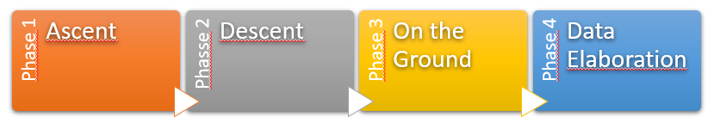

The following schema is referred to the CanSat organization workflow.

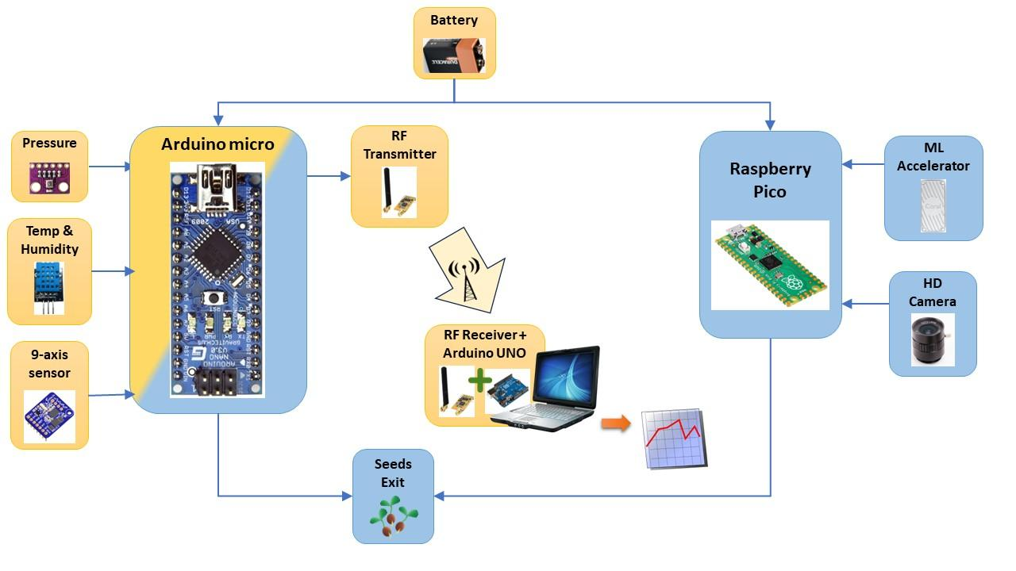

The nylon circular section parachute has a diameter of about 55 cm and will carry a CanSat with a weight in a range of 300 – 350 g, with an average descent ratio of about 6 m/s. These data permit us to estimate the drag coefficient by the following rule:

$$v=\sqrt{\frac{m∙g}{C_{r}∙\frac{πd^{2}}{4}∙ρ}} → C_{r}=\frac{m∙g}{v^{2}∙\frac{πd^{2}}{4}∙ρ}$$

where:

$$m=CanSat mass=0,35 Kg (assumed as maximum for simplification)$$

$$g=gravity acceleration=9,81 \frac{m}{s^{2}} (assumed as constant for simplification)$$

$$v=descent ratio≅6 \frac{m}{s}$$

$$d=diameter of parachute section=0,55 m$$

$$ρ=air density=9,81 \frac{m}{s^{2}} (assumed as constant for simplification)$$

Compared to the edition of the last year, a big difference in the competition is that the parachute is provided by ESERO, the model is reported below:

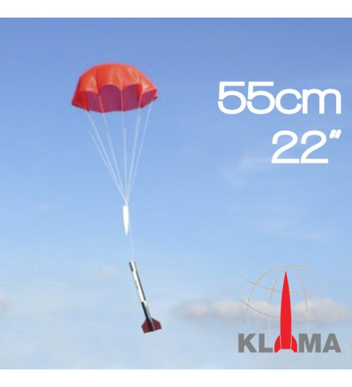

The CanSat uses two different sensors in order to measure air temperature and pressure, respectively DHT11 and BMP280. Due to the fact that both sensors measure the temperature, we use the average of the two measures to work with for the data plot. Thanks to the DHT sensor, we can also collect humidity data, even if it is not requested for the primary mission, but it will be interesting to analyze the amount of water vapor in different layers of the atmosphere. In addition, the sensor can also be useful in monitoring the humidity near the planting area when the CanSat is on the ground.

We used a professional weather station to calibrate the sensors through the software. This also permitted us to evaluate a possible overheating of the CanSat as a function of time that could cause a temperature/pressure/humidity data overestimation.

More details can be found in the following section, Tests.

The data we collected in this phase of the test can be found in the Github of the project, as mentioned in the References section.

## Mechanical design

The main structure has been 3D printed and PLA material was used for the purpose. The main body of the CanSat consists of a simple tube in which every component finds its place, from the microcontrollers, batteries to wires and different sensors. 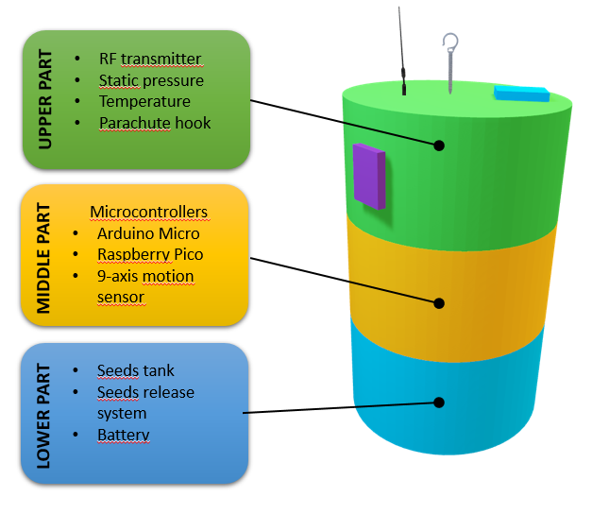

The CanSat can be divided by three different main parts, each of them having a specific role, according to the schema shown on the left.

We calculated the center of gravity of our satellite in order to install the 9-axis motion sensor.

For Bernoulli’s principle, the total pressure of the air is a constant and it is given by two contributions: static and dynamic pressure. It means that if we want to catch information about the static component, we have to act on the parallel air flow with respect to the direction of motion (as done with static ports in airplanes), while if we want to get information about the total, and then the dynamic component, we should act on the orthogonal face with respect to the direction of motion (as done with Pitot’s tube, to measure air speed). Therefore, the bmp280 sensor, mainly used to measure air pressure, is installed on the side of the CanSat, in order to measure the static component of the pressure.

The dht11 sensor, used to measure air temperature and humidity, is placed on the top of the satellite in order to avoid any disturbing effect of the air flow that could cause an over/underestimation in the measure.

The lower part of the CanSat is dedicated to the secondary mission. It contains the little tank with the seeds and the mechanism that will be used to release them.

When our CanSat lands, his feet are going to let it stay in balance. In the lower part there will be a camera and on one of the sides the seeds.

We are going to compress the seeds in a small clod of earth for each seed.

Once the CanSat is landed a mechanism will open half of the bottom and the seed will fall to the ground. Then two of the Cansat feet will retreat and it will fall to one side to let the plant grow and ensure that the sun's rays reach it. The camera will record the plant’s growth.

The following images represent the partial model used to perform 3D printing.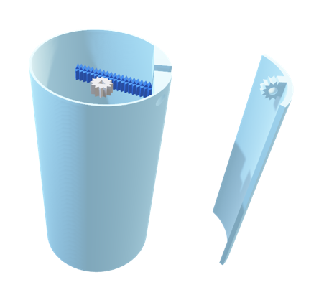 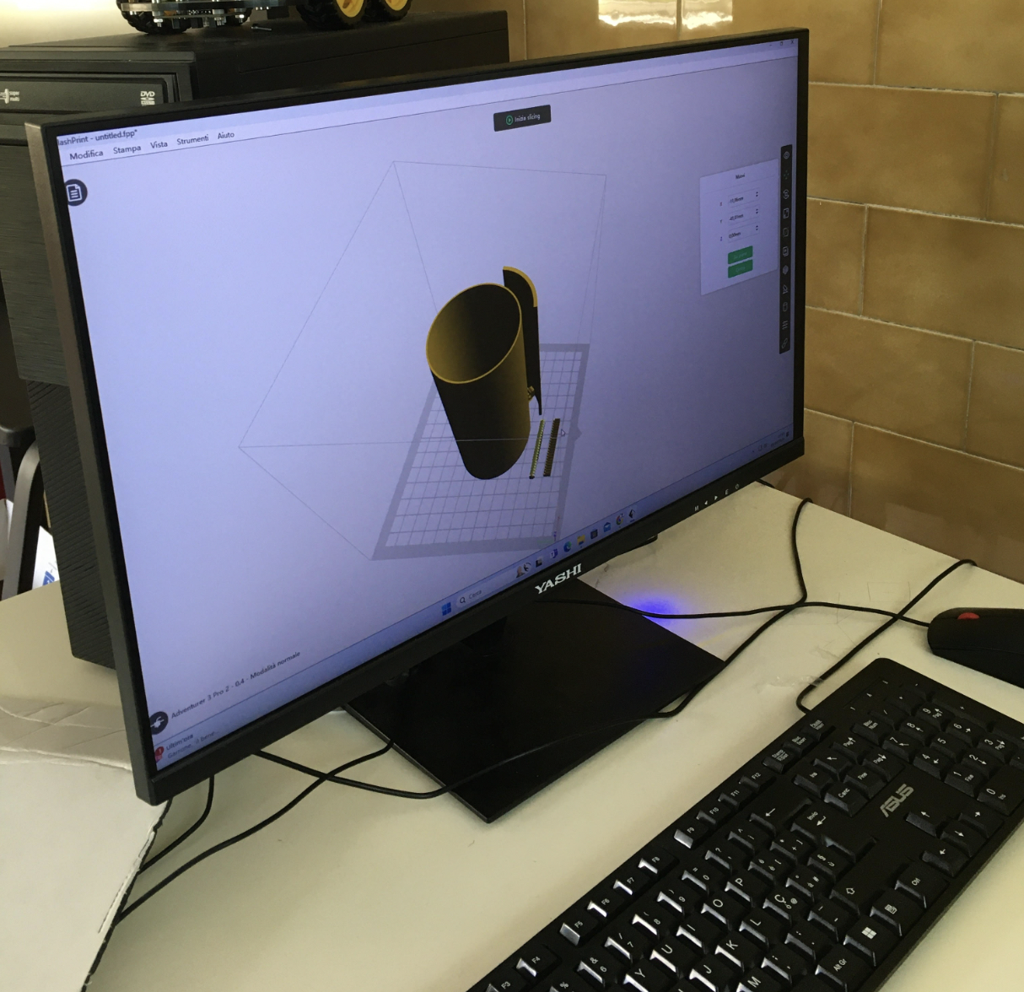

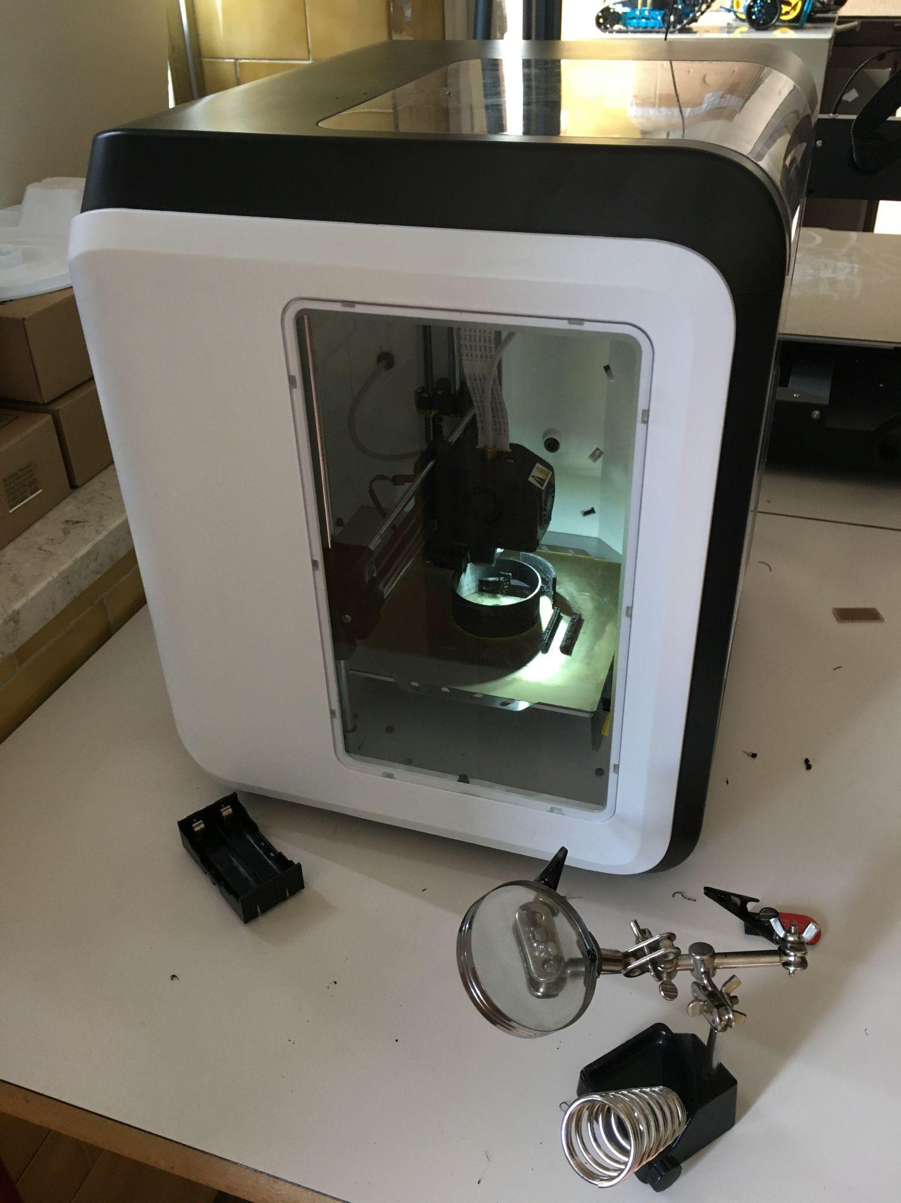The pictures show an airbrake on the right side of the CanSat. In the end we will have airbrakes in both side of the structure, for the moment the group was focusing on the single airbrake structure and opening system, in order to perform tests in the wind tunnel.

We don’t expect a sensitive drag increase during the descent phase opening the airbrakes, we are experimenting if, working on the connecting mechanism to the main body of the CanSat, we can use them for directing the satellite. This feature is still in the test phase and could be reviewed before the launch campaign.

## Electrical design

In this section we will provide electrical schemas and designs separately, to give better evidence of the single systems the CanSat is made of. In addition, to take photos and on the ground tests we used Arduino UNO R3 and Raspberry Pi, while we assembled the CanSat with the Arduino Micro and Raspberry Pi Pico for space and weight optimization.

The first system shown is used for the portable weather station with all the components we used for this purpose.

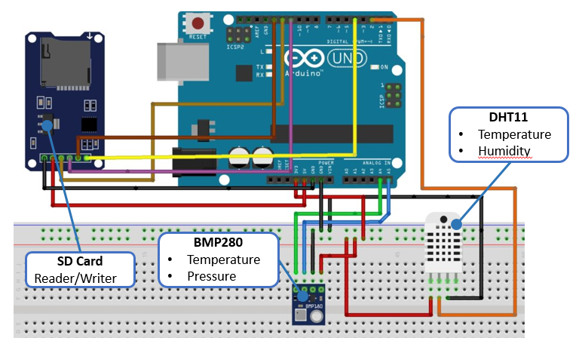 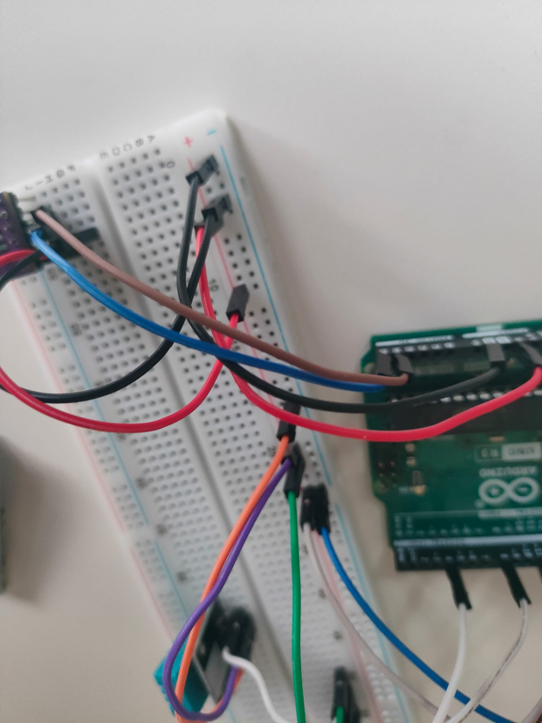

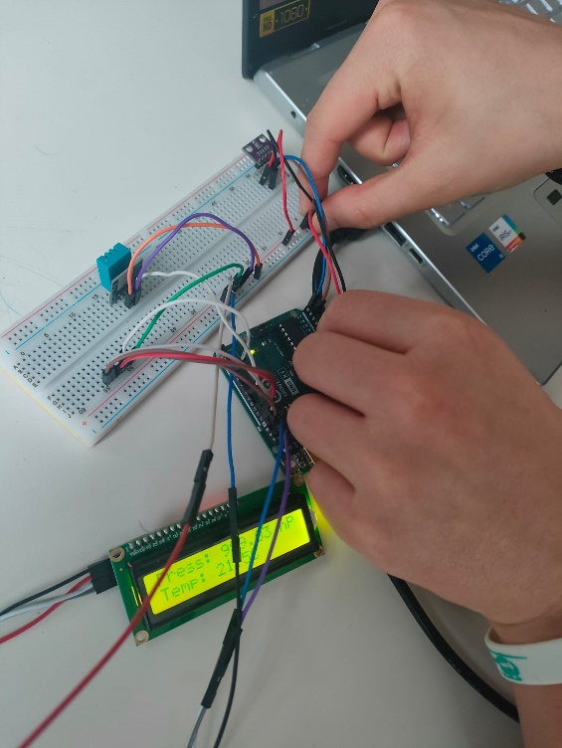

During the last year part of this team also participated at the AstroPi Mission SpaceLab competition. We want to emphasize on the importance of the resources we found out on the Esero platform in order to learn machine learning techniques, and how useful they have been this year with the CanSat competition.

## Software design

For what concerns the Arduino microcontroller and sensor measuring part, we used C++ code while in order to use Raspberry Pi, camera and Coral accelerator we had to switch to python code.

Codes can be found in the Github of the project, as mentioned in the References section.

How is famously known that *a picture is worth a thousand words*, we will describe used systems by means of the following schemas.

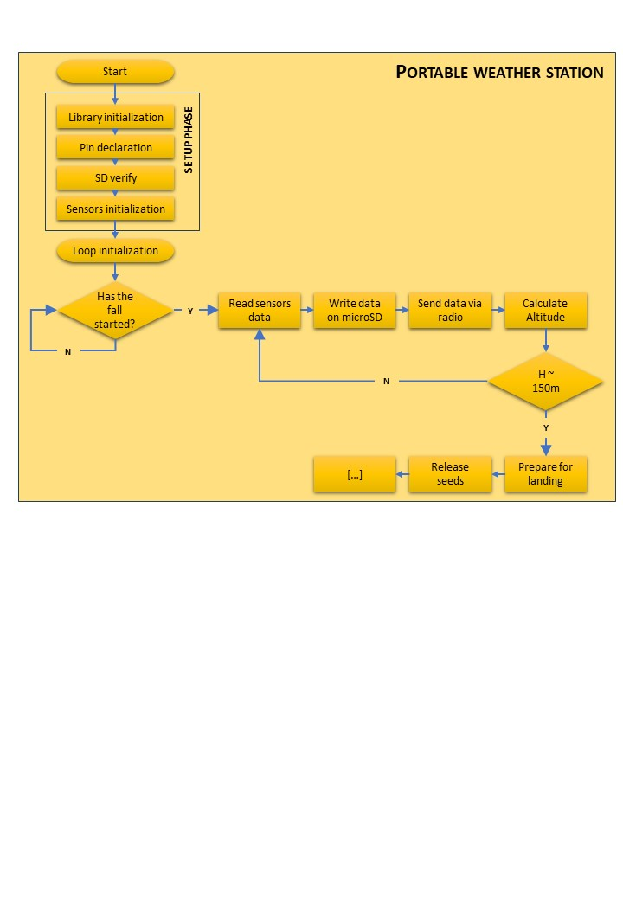

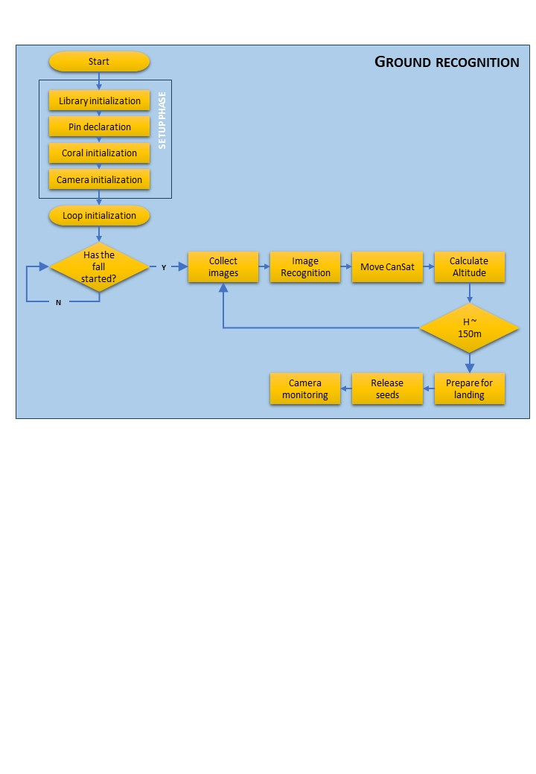

## Ground station

The ground station consists of one laptop, connected to an Arduino UNO R3 and a wireless Lora protocol radio Receiver, in order to record data sent by the CanSat.

We will perform real time data plotting by using the Arduino Serial Plotter and, once the CanSat will be on the ground, we will create graphs of collected data by means of two different technique: a python program and a small Excel worksheet, thanks to the csv file created during the acquisition. No additional operations are required in order to plot data.

## 

## Tests

* + 1. Calibration of pressure and temperature sensors

As mentioned before, in the primary mission presentation section, we used a professional weather station to calibrate our sensors. We realized that both dht11 and bmp280 provide accurate measurements of air temperature and pressure, for that reason no calibration was necessary via software. 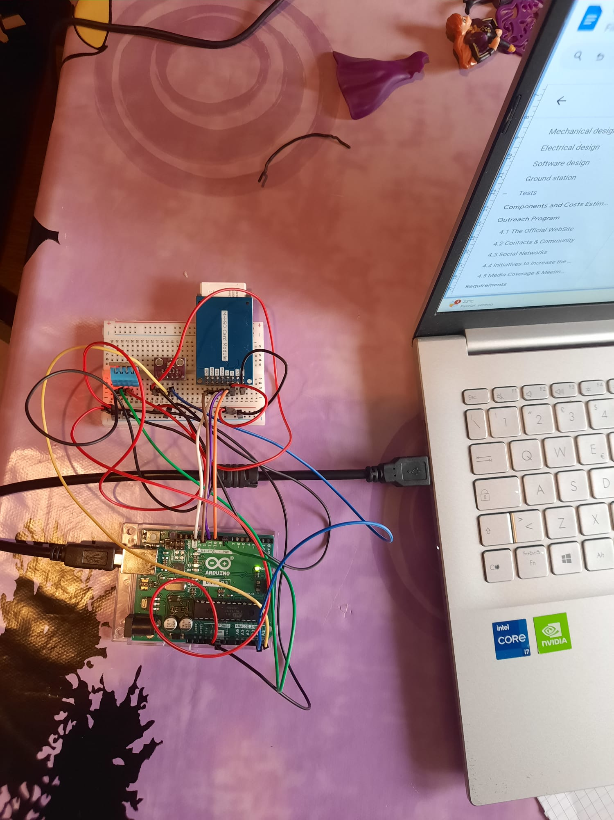

This is an image of both the portable weather station and the professional one, the last used for calibration tests.

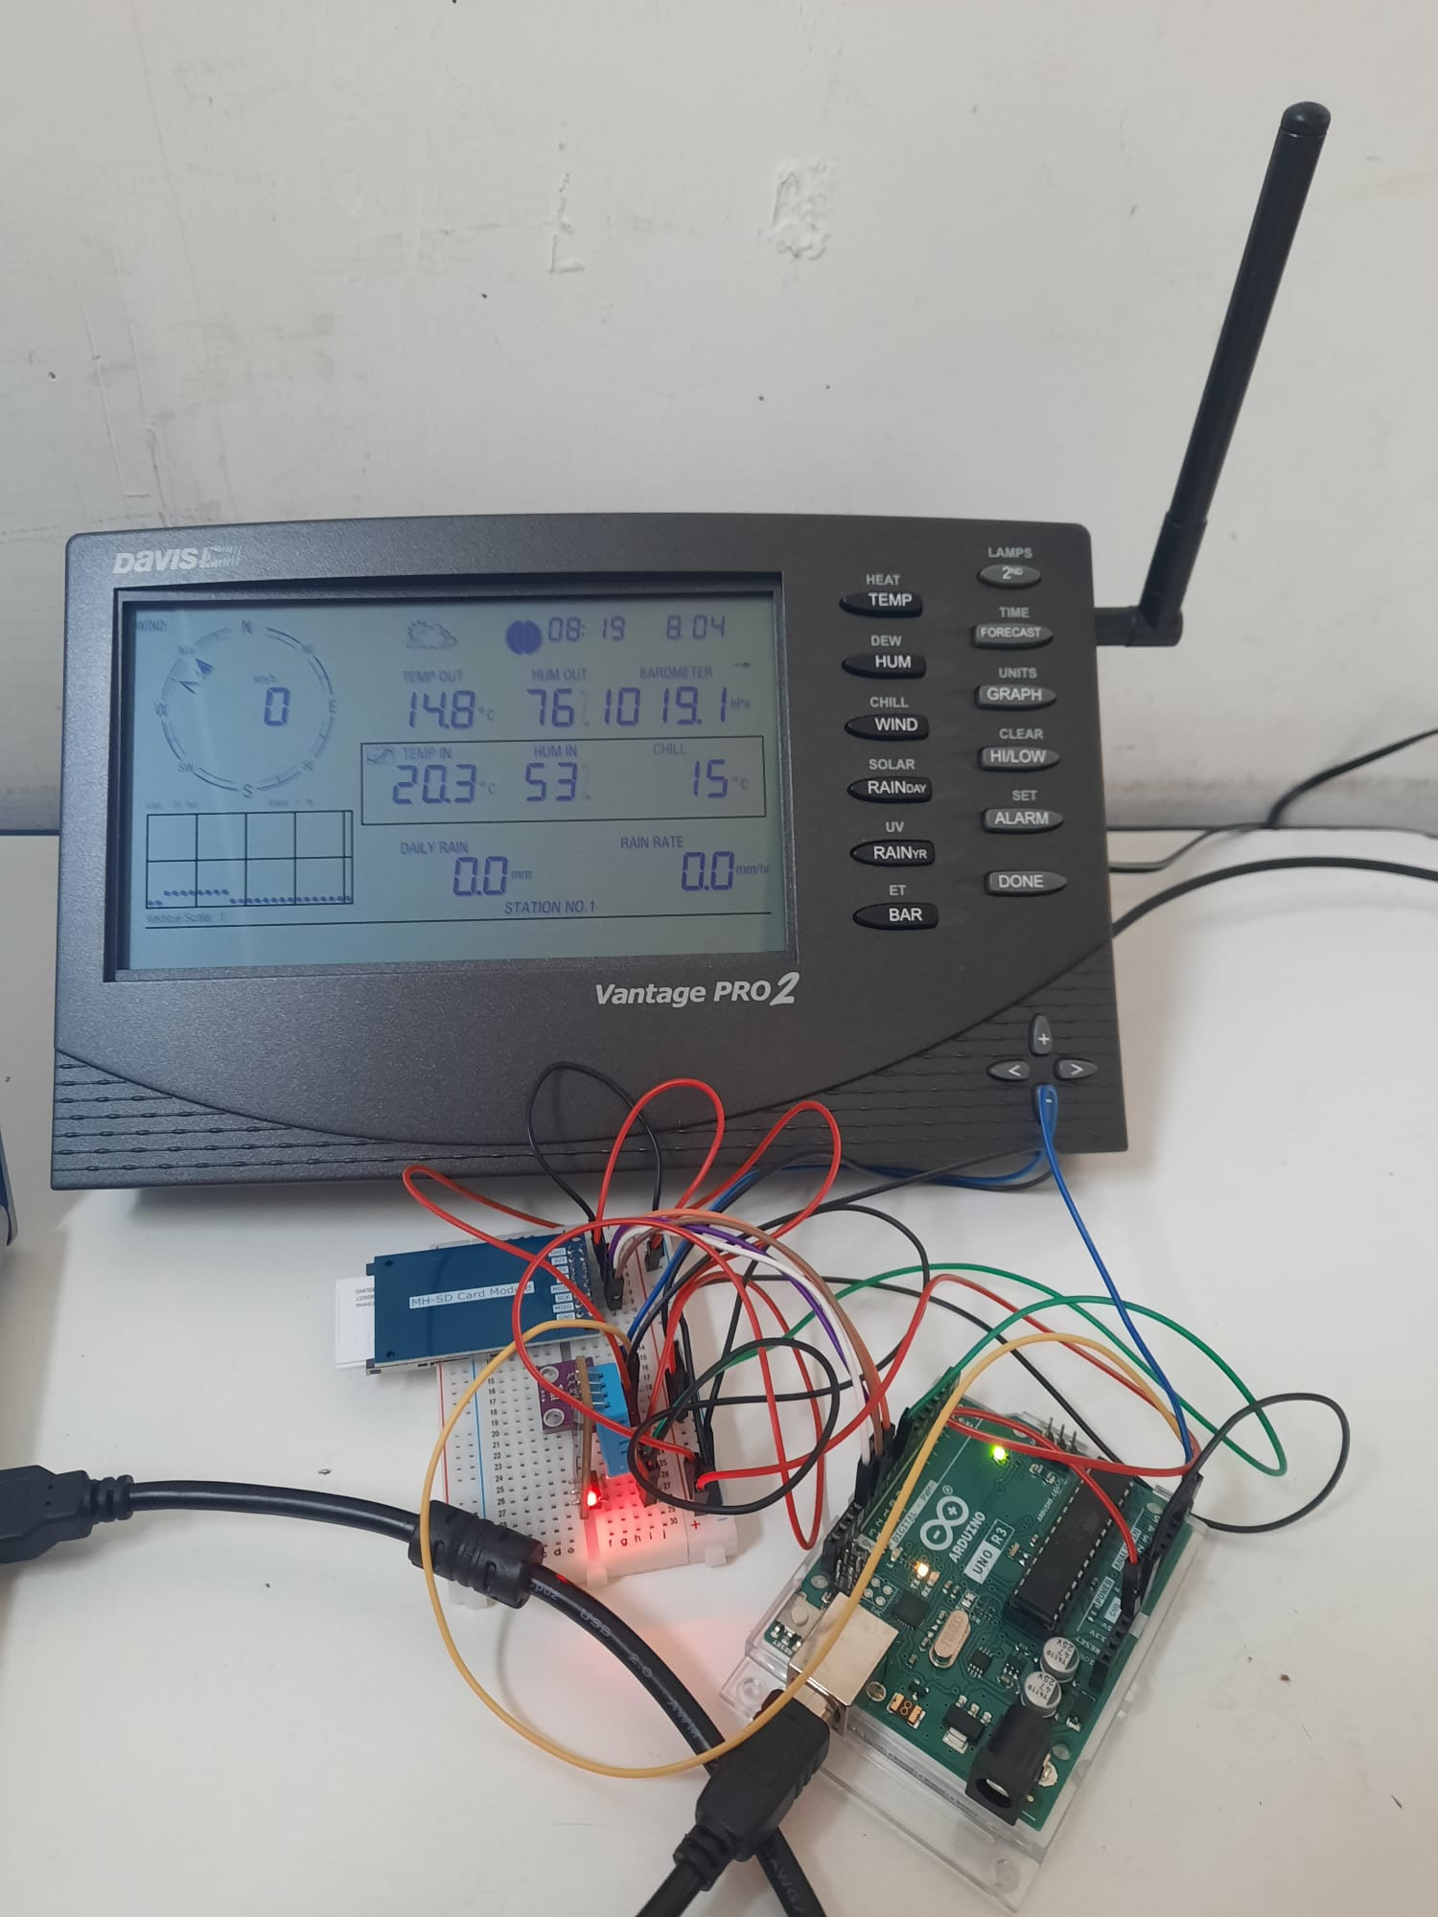

# Components and Costs Estimation

|  |  |  |  |  |
| --- | --- | --- | --- | --- |
| Component | Function | Quantity | Unitary Cost | Total Cost |
| bmp280 | Temperature and pressure measure | 1 | € 7,90 | € 7,90 |
| dht11 | Temperature and humidity measure | 1 | € 4,90 | € 4,90 |
| Lora wifi module | Wifi communication | 2 | € 14,90 | € 29,80 |
| SD reader | Arduino SD card reader/writer module | 1 | € 3,90 | € 3,90 |
| SD card | microSD card | 1 | €20,00 | €20,00 |
| Arduino Micro | Microcontroller | 1 | € 17,00 | € 17,00 |
| Essential Kit for Arduino | LEDs, sensors, wires, resistors, potentiometers, buzzer, buttons | 1 | € 10 | € 10 |
| MPU9260 | 9-axis control | 1 | € 22,00 | € 22,00 |
| OV5647 | 5Mpx HD Raspberry camera | 1 | € 24,00 | € 24,00 |
| USB Accelerator* | Coral USB Accelerator* | 1 | € 60,00* | € 60,00* |
|  | servocomandi | 5 | € 4,00 | € 20,00 |
|  | RC drone engine | 1 | € 10,00 | € 10,00 |
| PLA | 1kg PLA filament for 3D printing | 1 | € 15,00 | € 15,00 |
|  |  |  | **TOTAL COST** | **€ 244,50** |

*In the list we take into account the Coral Machine as a contribution for the total budget but with an estimated cost, because we already had it in school thanks to the participation in the AstroPi Mission SpaceLab project during the last year.

# Outreach Program

As a Team we decided to prioritized the completion of an engaging and effective communication project, seeking to promote public-team relationship.



## The Official WebSite

Our official website is at the base of the communication project.

Here you can find a lot of information about both the CanSat competition and the SatPlant project. Specifically, the "Cansat" and "Our Project" sections provide a complete idea of the competition and the primary and secondary missions.

By accessing the section "Our Project" you are redirected to three technical pages related to the secondary mission in which the main characters and the mode of operation of the satellite are treated in detail. Here, the communication of technical aspects takes place both in writing and graphics, through the insertion of summary infographics and the illustration of the project through the division into three main phases: Descent Phase, Ground Phase and Plant Monitoring. This logical division coincides with that actually followed by us during the design of the CanSat, demonstrating a transparent communicative approach.

The website has been registered and is available on the main search engines and to promote both national and international audiences, the site is also available in English.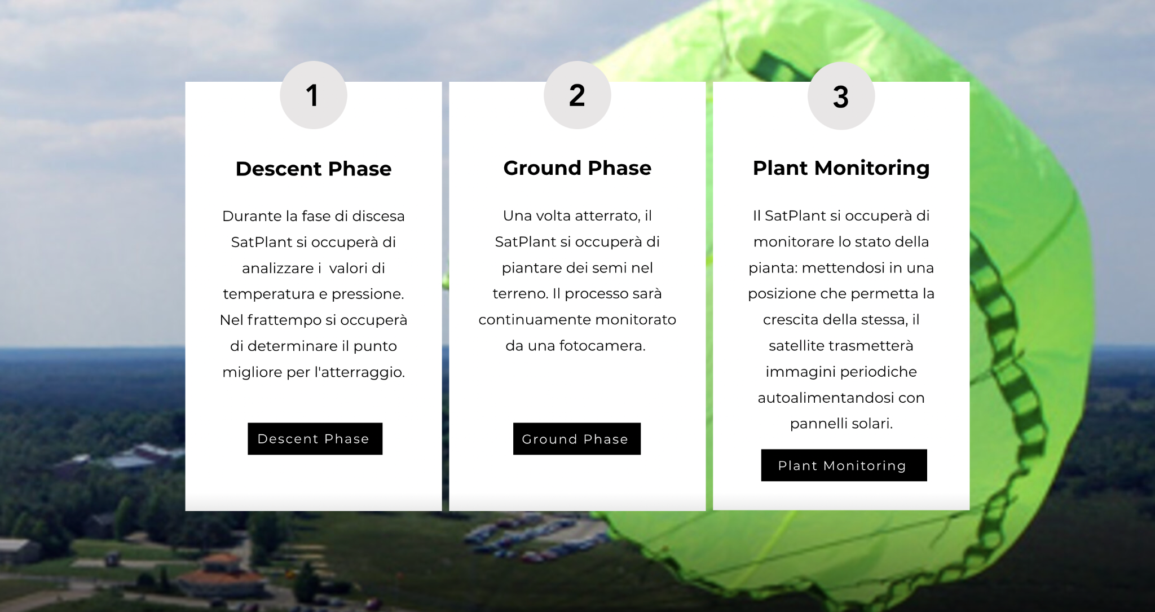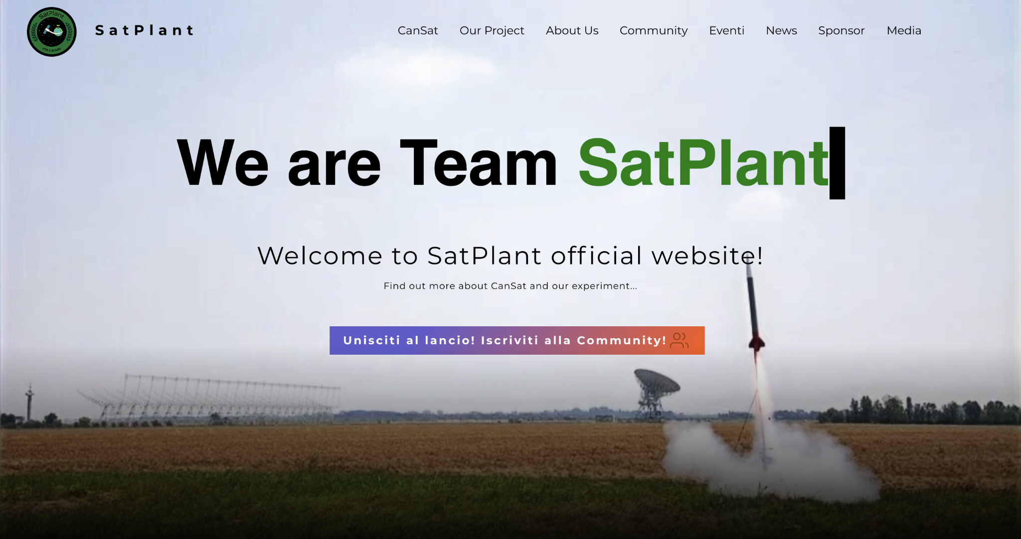

In the images above, on the left the HomePage of SatPlant’s official WebSite, on the right the “Our Project” section and the division into three main phases.

## Contacts & Community

Interested people can easily get in touch with us through the Reddit community and the link to the "Contacts" section. These are always viewable and placed at the bottom of the website.

The Community offers various possibilities:

* by entering an email address on the website you can receive updates as soon as news are published (newsletter). The emails are always composed by a direct link to the news section, from which you can access the archive of the published news and follow the progress and the most important results achieved.
* Reddit instead offers the opportunity to participate in discussions by interacting directly with us. Here you can deepen specific issues and provide advice.

## Social Networks

Social networks also help to inform the public about the progress achieved. Further to this point, we decided to adopt different communication strategies among the social networks used.

We want to notice that in order to adopt a transparent approach, it has published online not only positive results but also some difficulties encountered during the work.

The diagram below illustrates the main features of our social network profiles.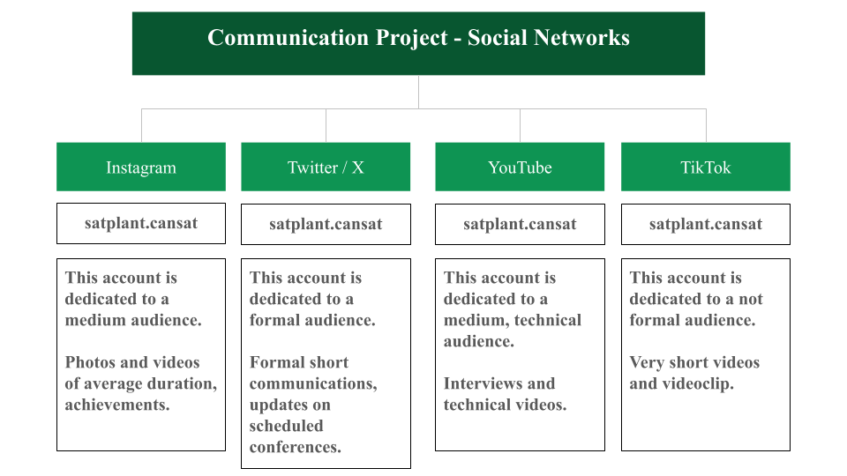

## Initiatives to increase the number of supporters and involve the public in the National Launch Campaign

In addition to the project declared during the selection phase, we have chosen to offer a unique opportunity to our supporters. Those who enter their name and email on the website and subscribe to the newsletter can choose, during registration, whether to have their name transmitted from the CanSat to the ground during the national launch campaign. It is an initiative aimed to increase the interest of outsiders and encourage the public to follow the project up to the launch campaign to see their name transmitted from the satellite to the ground, thus involving them directly.

## Media Coverage & Meetings

To ensure media coverage, the link to the SatPlant’s website has been added to the school’s website. This has allowed an increase in online traffic, and it is expected to increase further in the coming weeks.

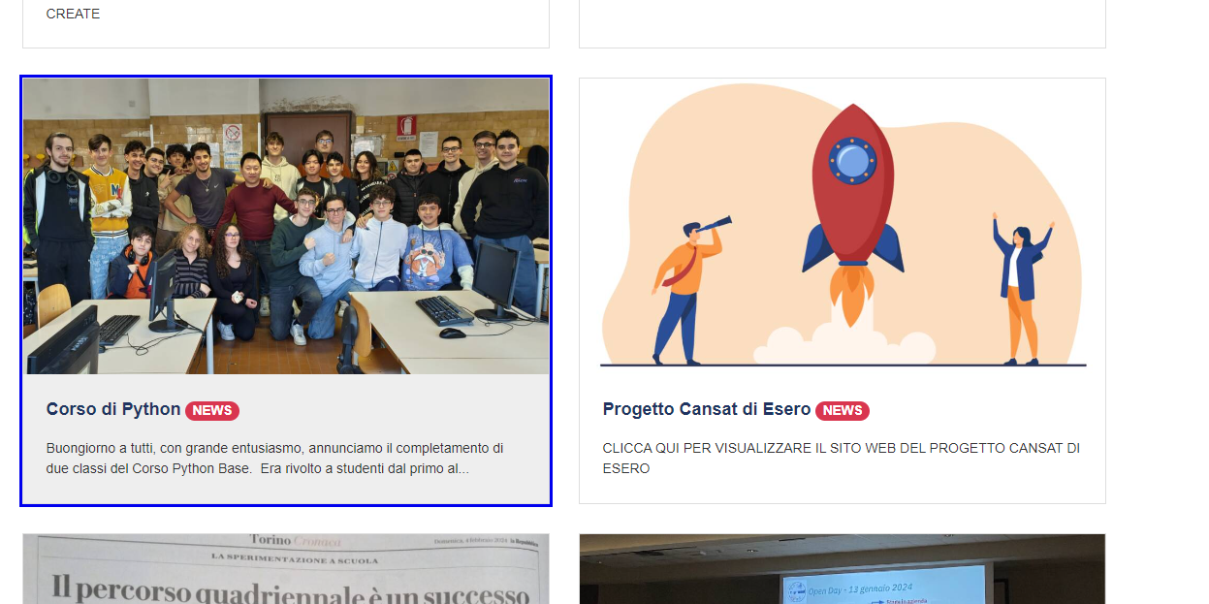

At the same time, we are organizing a meeting in our institute to be held the week immediately before the launch campaign in order to offer the opportunity to meet in person some students who have expressed their interest, as mentioned in the pre-selection report.

# Requirements

|  |  |  |  |
| --- | --- | --- | --- |
| **Feature** | **Unit of measure** | **Request** | **Project** |
| CanSat Height | mm | 115 | 115 |
| Diameter | mm | 66 | 65 |
| Mass | g | 300-350 | 300-350 |
| Dangerous material |  | Absent | Absent |
| Autonomy | h | 4 | >4 |
| Battery |  | Easy change | Easy change |
| Recovery system |  | Recommended | Present |
| Local data writing |  | Recommended | Present |

# References

|  |  |
| --- | --- |
| Website | Link |
| Our Website | <https://teamsatplant.wixsite.com/cansat2024> |
| School Website | <https://www.itisgrassi.edu.it/pagine/progetto-esero-1> |
| Our GitHub | <https://github.com/DaniSquotty/SatPlant_23-24> |
| Our Drive | <https://drive.google.com/drive/folders/115dy5hI_us74epCh_WJrisXIxlSjNN_-?usp=drive_link> |

Different links used for social media accounts can be found on the website.

# Appendix 1 – Sensors calibration

Data collection for sensor calibration. We provide an abstract of the data collected during the calibration test and a plotting example of temperature and pressure.

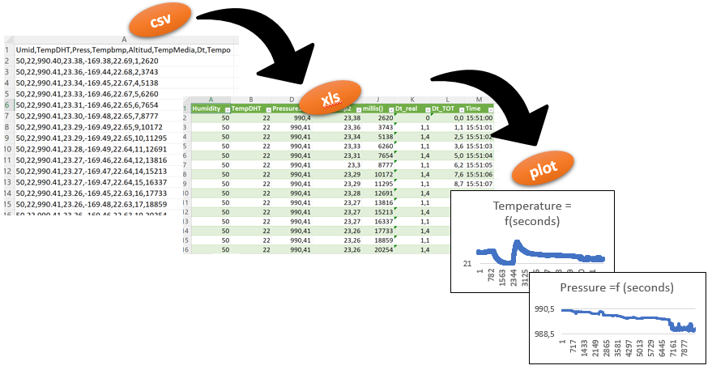

Here some rows of the csv file generated during data acquisition:

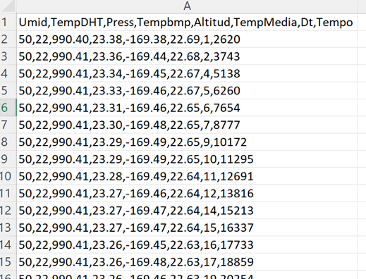

What follows are the same rows but in Excel format:

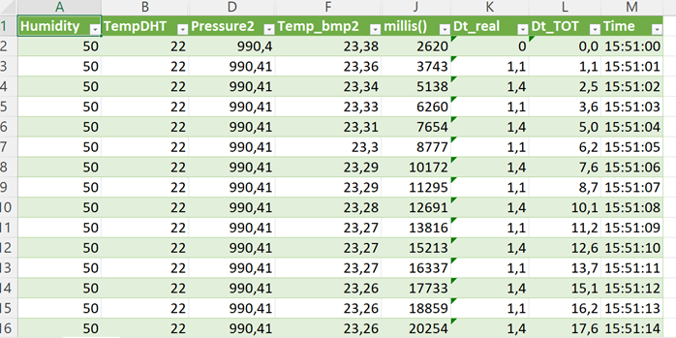

The respective graphs of temperature and pressure.

